
The City of Leon Valley City Council is seeking an experienced Finance Officer to be the next …
Finance Director

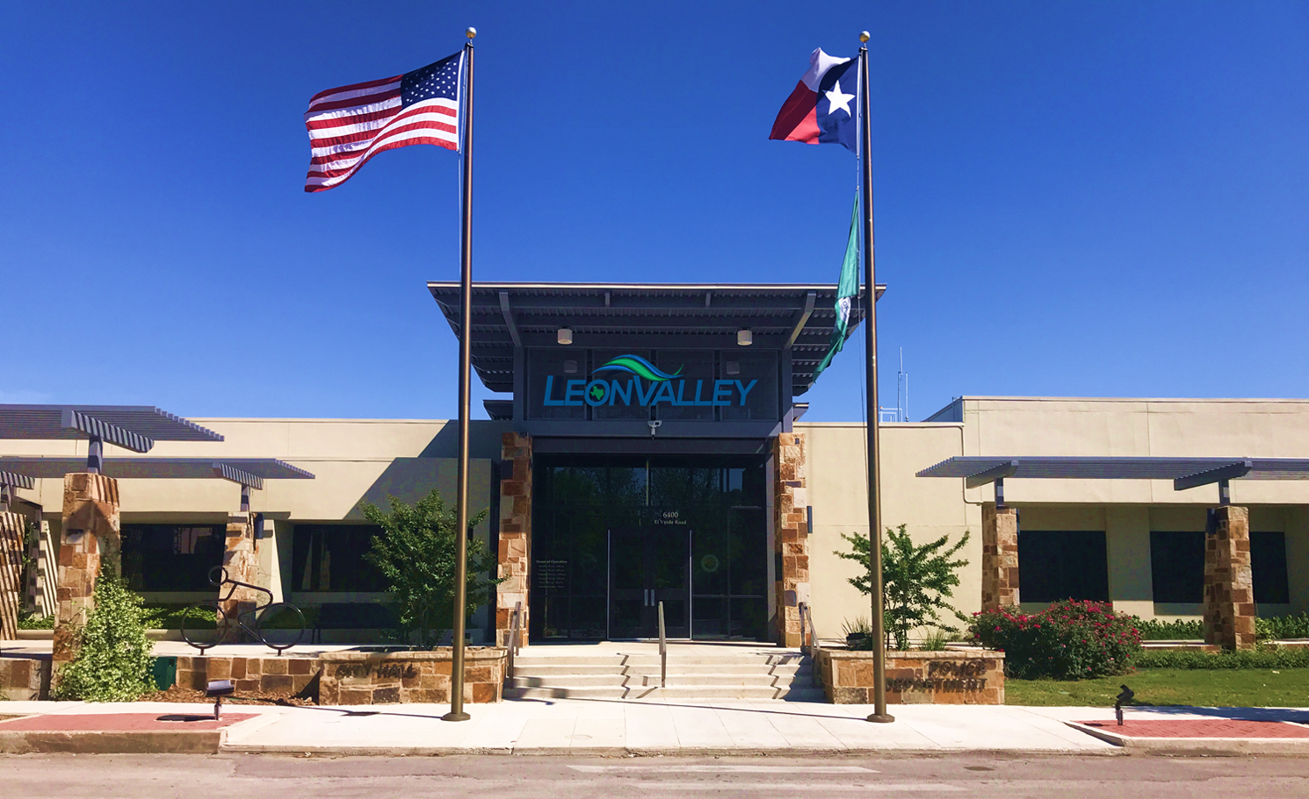

The City of Leon Valley was incorporated on March 31, 1952, when the local residents became aware that the City of San Antonio was preparing to annex the area.

The City of Leon Valley is a Home Rule City operating under a Council-Manager form of government with a Mayor and five City Council Members elected at-large. The Mayor and City Council Members hold two-year terms of office and are elected and serve on an at-large basis. The City, home to 11,000 plus residents, is located in the northwest quadrant of Bexar County, 10 miles from downtown San Antonio. The heart of Leon Valley lies along State Highway 16, also known as Bandera Road, and is made up of approximately 3.5 square miles.

The City is a full-service city with public safety departments including the Fire Department, Emergency Management Services, Police Department and a superior water system. Operational departments include: Administration, Planning and Zoning, Economic Development, Finance, Leon Valley Public Library, Municipal Court, and Public Works departments. The City employs approximately 121 employees and has a 2020-2021 budget of $12.2 million.

The City of Leon Valley maintains extensive budgetary controls, resulting in a AA bond rating. We have received the Certificate of Achievement for Excellence in Financial Reporting for the last 10 years. Please visit our Financial Transparency page: https://www.leonvalleytexas.gov/finance/page/truth-taxation-information

Requirments
Must have a minimum of bachelor’s degree in Finance, Accounting, Business or other related fields (experience substitution for education may apply). Must have a minimum of three years of governmental financing. Valid Texas Motor Vehicle License with the ability to remain eligible to drive under the City’s driver evaluation program. Must be bondable under City's public employee and fidelity bond coverage.

Benefits and Salary
- Salary Range depending on qualifications. Please include your minimum salary.
- Possible paid moving expenses.
- Eleven (12) paid holidays per year
- Minimum of seventeen (17) eight-hour days per year of Personal Leave
- Minimum of twelve (12) eight-hour days per year of Major Medical Leave
- 100% employer paid group health, and dental insurance, with dependent coverage available
- Participation in a pension plan through the Texas Municipal Retirement System. 7% and 2:1 match
- Voluntary participation in I.C.M.A., a Section 457 Deferred Compensation Plan
- Section 125 Cafeteria Plan, to include health and dependent care reimbursement accounts
- $10,000 Term Life + AD&D, paid by employer
- Medical and family leave programs
- Paid Funeral leave
- Employee Assistance Program (EAP)
- Worker’s Compensation
- Social Security
- Career Training Opportunities
- Four Day Work Week

Submit resume with minimum salary requirement to Lisa Hernandez, HR Director, l.hernandez@leonvalleytexas.gov or mail to 6400 El Verde Road, Leon Valley, Texas 78238-2399 or remit by fax to (210) 684-1515. For additional information about the City of Leon Valley, see our website at: www.leonvalleytexas.gov. Closing Date: February 6, 2023, at 5:00 p.m.

